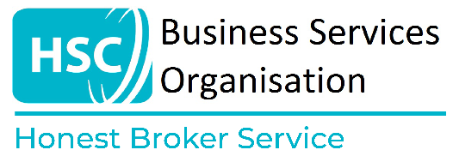

**HBS Researcher Output Checklist**

Please confirm that your output meets the following minimum requirements. Outputs not meeting all of these requirements will not be released:

I have undertaken an initial disclosure control check of my work and confirm that my output meets the minimum requirements outlined in the [HBS Research Output Checking Procedures](https://bso.hscni.net/directorates/digital/honest-broker-service/honest-broker-service-researcher-access/metadata/).

All outputs are clearly labelled, with underlying unweighted counts provided for all figures, graphs, models, and other visual elements.

All figures and graphs are fixed images.

There are no hidden columns or tabs in any Excel file.

I am not requesting a data file or dataset.

Tables are properly formatted and sufficient explanation on data used, methodology, and what each aspect of the output shows has been included.

Only outputs that are necessary have been included; no additional tables or results produced are submitted.

I have not resubmitted tables or results that have already been cleared, nor have I added new results to a previously cleared file. Only new outputs are being submitted for clearance.

There are no cell counts below 10 (unweighted), except where counts relate to missing data. Zero counts are permitted only if they are structural zeros (e.g. the number of COVID-19 vaccinations administered in 2018, prior to vaccine approval in December 2020).

I have ensured that small counts cannot be derived from totals within the table or across other outputs.

I have reviewed all code file comments to ensure there are no references to small counts.

I am not requesting minimum or maximum values.

Medians have been calculated using data from at least 20 individuals.