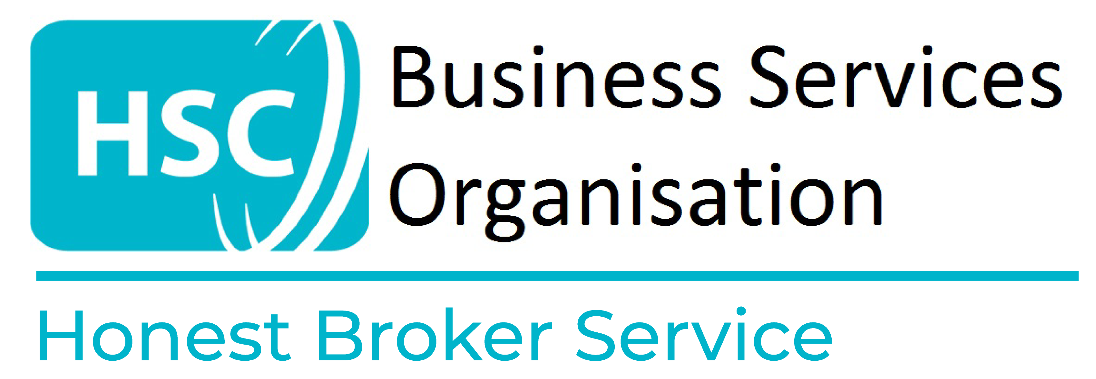

Honest Broker Service Project Modification Request Form

It should be noted, as a result of the data anonymisation processes used by the Honest Broker Service, any requests for additional variables or datasets will result in new Study IDs being applied to all datasets belonging to a specific research project.

FOR COMPLETION BY PROJECT TEAM MEMBER

1. Project Number | Date of Modification Request

2. Project Title

3. Researchers to be added (if applicable)
1.

2.

3.

4.

4. Summary of Modification Request e.g. expanding to more groups, more variables, more up-to-date data, extension of project

5. Impact on Project
Does the proposed change alter the aims/objectives of the project? Yes/No
If yes, how?

Does the proposed change increase/reduce the robustness of the methodology? Yes/No
If yes, how?

Does the proposed change increase/reduce the probability of the outcome being achieved? Yes/No
If yes, how?

6. Project Extensions only complete this section if you need to extend the study duration beyond the proposed dates in your application.

Project Start Date: | Current End Date (as stated on the HBS Research Application Form):
Length of extension required included new proposed end date:

Reason for extension request:

7. Chief Investigator Signature – Chief Investigator of the project must sign to authorise modification request.

CI Signature:

CI Name:

Date:

FOR COMPLETION BY HONEST BROKER SERVICE

Date Request Received | Cleared by HBS | Clearance Person
 | Yes / No
Date Decision Taken | Through HSC DAC
 | Yes / No
Cleared by HSC DAC | Date HSC DAC Cleared
Yes / No
Clearance Clarifications, limitations and recommendations
Any Further Comments

