Community Falls
Prevention and
Management Service
Scan me
for further
Information
To refer to the BHSCT Community Falls Prevention and Management Service the person must:
- Reside in the Belfast Trust Area
- Be 65 years and above
- Consent to referral

Name: GP Name & Address:
Address:
DOB:
Telephone Contact Details:

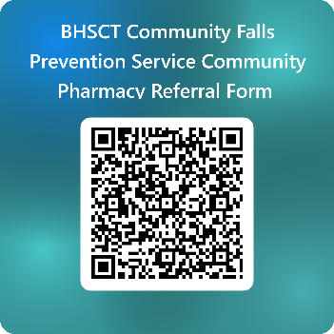
Has the patient fallen / a fear of falling Yes / No

How many falls in the past 12 months

Has the patient identified walking or balance issues Yes / No

Is the fear of falling restricting the patient’s daily activities Yes / No

Supporting Information/Comments: (nature of falls/indoors Vs outdoors/time of day/dizziness on changing position/cognition/social support/high risk medications/previous referral to Falls Service):

If the patient’s falls are unexplained eg fainting or loss of consciousness or due to excess alcohol consumption: Please do not refer to the Community Falls Prevention and Management Service.
Please forward the completed form to: fallsservices@belfasttrust.hscni.net or alternatively scan QR code above

