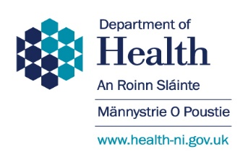
Appendix B:

Community Pharmacy Care Home Support Service (CPCHSS)

Level 1 Care home service agreement form

Period of Agreement

The community pharmacy should complete a separate care home agreement form for each care home for which it provides the service.
A copy of the service agreement should be retained in the community pharmacy for the duration of the service.

Service Eligibility

The community pharmacy must hold a contract with SPPG to provide the service.
The service will be available to all nursing and residential care homes who are registered with RQIA and are commissioned on an individual care home/community pharmacy basis, i.e. the care home can only receive the service from one community pharmacy.

The community pharmacy should be the pharmacy that provides the routine dispensing service to the care home.

Service Outline

The service will be provided in accordance with the SPPG Community Pharmacy Care Home Support Service Specification document.
Two scheduled visits to each care home will take place during each financial year e.g. 1st April 2026 to 31st March 2027.
Each visit will include completion of the Medication Audit Support Tool and the provision of advice on medicines management to staff within the care home.

Named Contact in Each Organisation

PHARMACY DETAILS:

Name of Community Pharmacy: ________________________

Name of Pharmacy Contractor: _____________________

Signature: ___________________________

Date:_________

CARE HOME DETAILS:

Name of Care Home: ________________________

Home Type - Nursing/Residential: _______________

Care Home Address: _______________

Name of Care Home Manager: ______________

Signature: _________________

Date: ________

