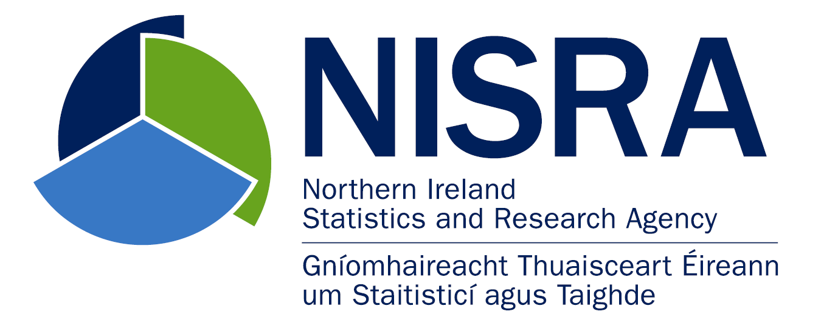 | 

FPS Information Unit Customer Satisfaction Survey 2025/26
This survey was run in March 2026, utilising an online questionnaire (created in Citizen Space), and was issued to all of the key customers who had received a service from Information Unit in the previous business year - it had 35 responses. In terms of overall satisfaction, a separate exercise was conducted by the Honest Broker Service, where a more detailed e-questionnaire was issued to their research customers but which contained the same overall satisfaction question - and a further 8 responses were received to this.

1. Overall Satisfaction
Question asked: Overall, how satisfied are you with the overall service provided by the Information Unit during 2025/26?
This question received 35 responses from FPS and a further 8 from the Honest Broker Service
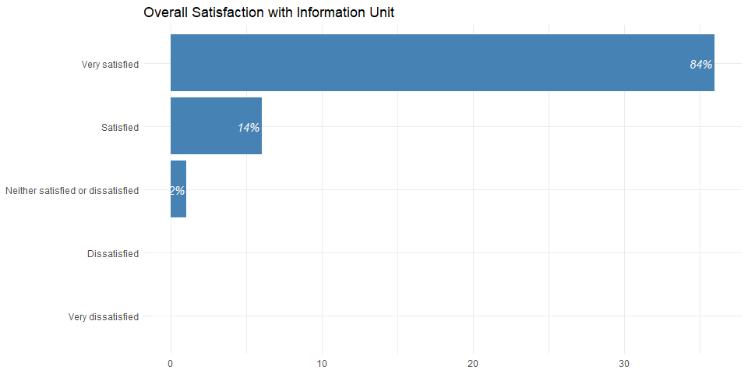

98% of respondents were at least satisfied with the service received with over 4 in 5 (84%) very satisfied.

2. Specific Aspects Relating to the Information Unit (FPS)
Question Asked: To what extent would you agree with the following aspects of your contact with the Information Unit during 2025/26?

(a) Information Unit staff are knowledgeable
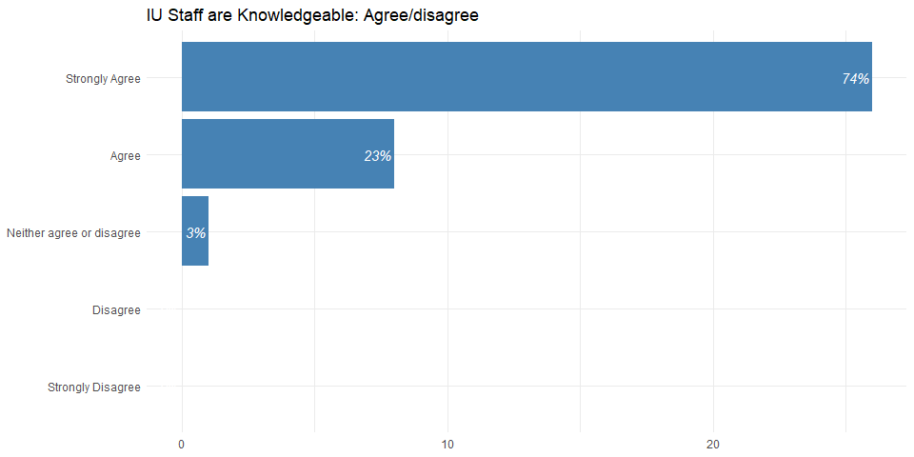

97% of respondents agreed that IU staff were knowledgeable, with almost three quarters (74%) strongly agreeing.

(b) Information Unit staff respond to my queries promptly
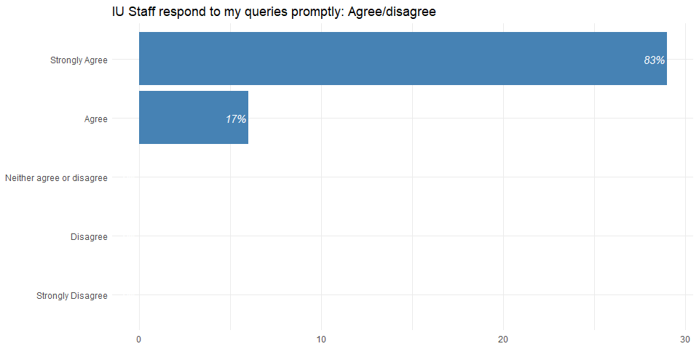

All respondents agreed that staff responded to their queries promptly with the vast majority (83%) strongly agreeing.

(c) Information Unit staff are helpful
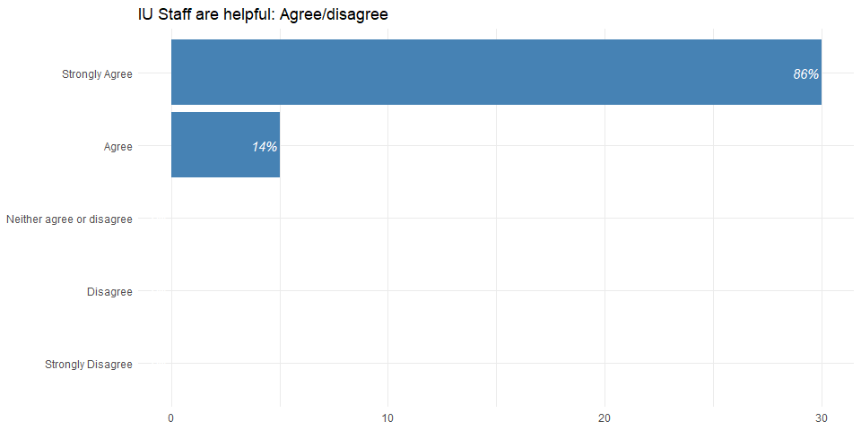

All respondents agreed that staff are helpful with the vast majority (86%) strongly agreeing.

(d) Information Unit staff are courteous and treat customers with respect
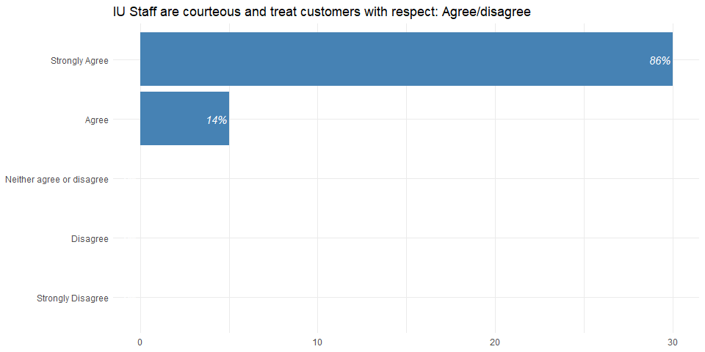

All respondents agreed that staff are courteous and treat customers with respect, with the vast majority (86%) strongly agreeing.

(e) Information Unit staff engage with their customers and stakeholders
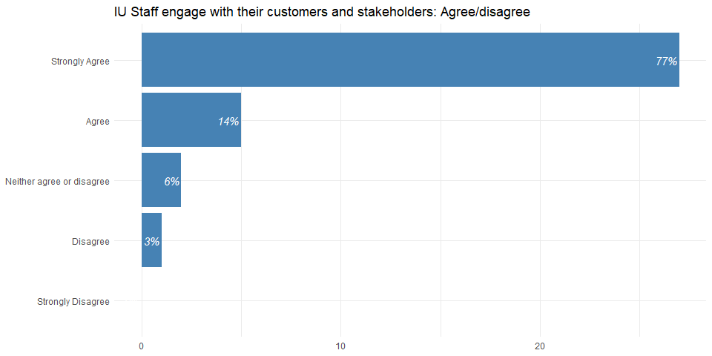

91% of respondents agreed that staff engage with their customers and stakeholders, with over three quarters (77%) strongly agreeing.

(f) Information Unit analysis informs my work
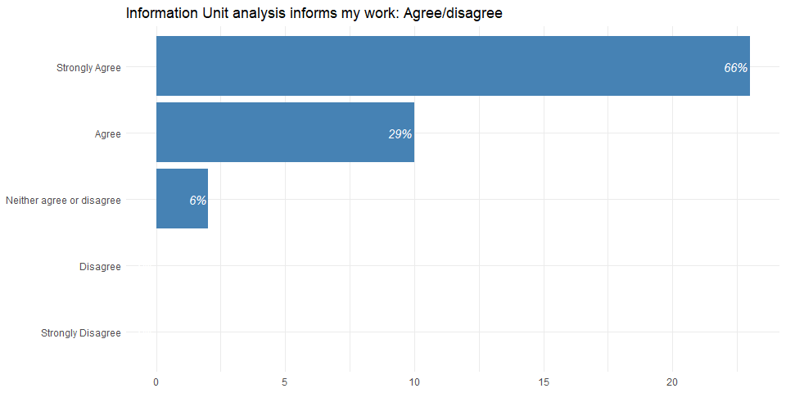

94% of respondents agreed that IU analysis informed their work, with two thirds (66%) strongly agreeing.

(g) Information Unit analysis is presented and explained clearly
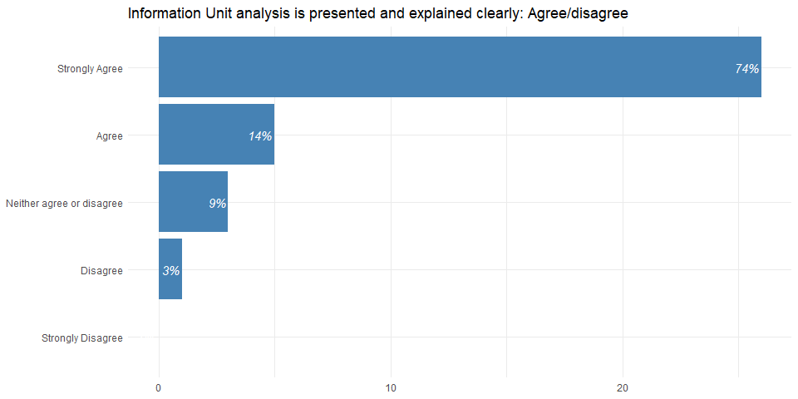

88% of respondents agreed that IU analysis is presented and explained clearly, with almost three quarters (74%) strongly agreeing.

3. Services Used by Respondents
Question asked: BSO Information Unit provides services across a range of areas. Which of the following services do you use? (Note that respondents could choose more than one option.)
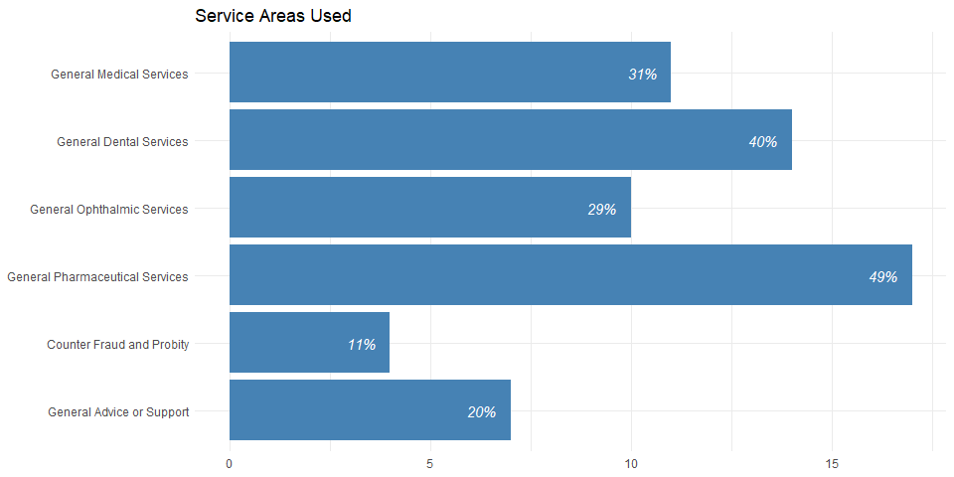

General Pharmaceutical Services were used by almost half (49%) of all respondents whereas only around one in ten (11%) used Counter Fraud and Probity.

4. Respondent’s Role
Question asked: which of the following sectors best describes your role?
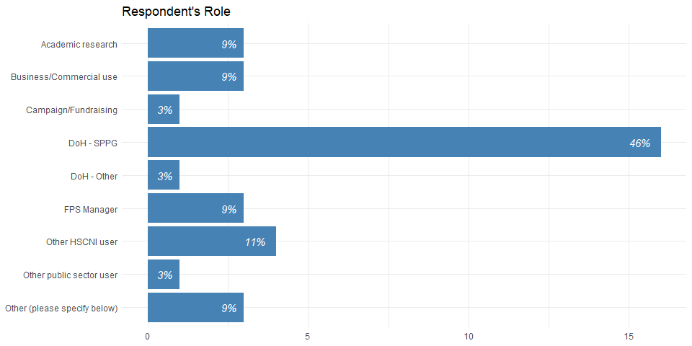

The largest proportion of respondents were from the Department of Health’s Strategic Planning and Performance Group (SPPG), who commission the Info Unit’s analytical work programme, with approaching half (46%) drawn from this background.

5. Additional Comments
Respondents were asked if they had any additional feedback. A range of the feedback has been included below:
- An outstanding team, in terms of knowledge, competence and willingness to support and engage.
- The Information Unit is a team I can rely on completely to respond to my requests promptly and efficiently. They are consistently helpful, professional, and approachable. Thank You & keep up the good work.
- I engage with the FPS Information Unit frequently in respect of information being processed on behalf of SPPG. The staff are helpful, knowledgeable and supportive and I’ve no issues or concerns with the work/assistance they provide. On a wider note I think the overall relationship between SPPG and BSO would benefit from some attention, there is clearly a need to review roles and responsibilities and document these in up to date service level agreements.
- My interactions were in relation to primary and secondary care prescribing data. On each occasion the response was almost by return and further questions were answered clearly and quickly.
- Always excellent help and support from the IU staff - wonderful in all they do.
- Always professional, responsive and agile, the outputs of IU are trusted and valued and a key component to planning, managing and assuring services and outcomes.
- IU staff are always extremely helpful and constructive in facilitating any requests - taking time to consider the request and advising on options based on their expertise. Ultimately, this means the requests are more suited to my needs.
- Engage in relation to customer needs before making changes to what and how data is captured and data layout.
- Excellent service.
- Extremely helpful - SPPG relies heavily on the expertise of all staff
- Information Unit are a vital support to delivering our business and the team are very approachable and flexible. The official statistics are particularly helpful in answering AQs & CORs and informing business planning.

